

INSTALLATION INSTRUCTIONS
For Flamora 210 fireplaces, Capri / Salento / Parma / Voltera

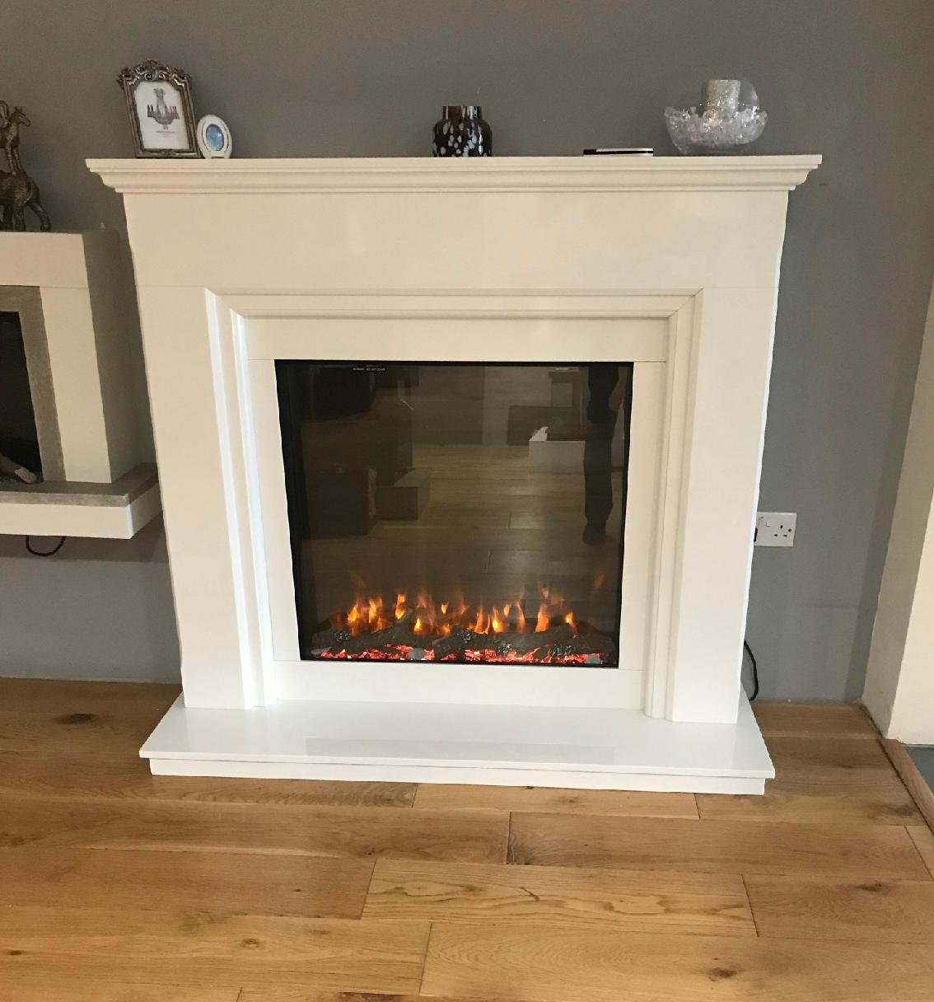

List of components.

*Package containing fixing clips, screws & rawl plugs
*Fireplace components & electric fire, numbered as follows:

No. 1 Hearth
No. 2 Electric Fire, including separate instructions
No. 3 Left leg of main surround
No. 4 Right leg of main surround
No. 5 Bottom slip from 4-piece slip set
No. 6 Left slip from 4-piece slip set
No. 7 Right slip from 4-piece slip set
No. 8 Top slip from 4- piece slip set
No. 9 Centre panel of main surround
No. 10 Shelf/Mantle of main surround

Important Information - These instructions are for your safety.
Please read them thoroughly before use and retain for future reference.
Failure to follow them may result in serious or fatal injury and/or property damage.
Before you begin the installation, please ensure that a full and detailed inspection of all component parts is undertaken jointly by the installer and purchaser to ensure there is no damage or manufacturing defects with the product. Once the fireplace has been installed, no claims or responsibility will be accepted by the manufacturer relating to chips, scratches or any other obvious defects. Please also ensure you carefully read and fully understand these instructions before commencing installation as we cannot accept responsibility for any damage or defects caused by non-compliance with these instructions. This fireplace should be installed only by a competent professional fireplace installer and fitted only to suitable sound surfaces.
NOTE: Installation is not recommended as a DIY or single person task. In addition to this giving rise to the potentially increased risk of product damage and/or incorrect installation, it should also be noted that some marble components can be very heavy and will require two people to lift/handle. Caution should always be exercised if attempting to lift heavy or awkward objects. Always ensure the wall and floor have sufficient load bearing capabilities to allow the surround to be installed safely and securely. The foundation must be sufficient to support the entire weight of the surround.

Fitting Procedure:

*Before building the fireplace, consideration will need to be given to the routing of the power supply to the fire. This will affect the stages of the installation process.
We advise a qualified electrician to engage with any electrical aspects of the installation.

*Position No. 1, the hearth on a sound level floor in a bed of mortar.
*Position No. 2, the electric fire centrally on the hearth and sitting back against the wall.
*Position No. 3 & 4, left and right leg, on top of the hearth, and fix each to the wall using the fixings provided.
*Position No. 5, bottom slip, on top of the hearth, and using a two-part marble mastic e.g. Tenax, glue No. 5 into place.
*Move No. 2 the electric fire forward to find it's resting place up against the back of No.5, bottom slip.
*Using some cardboard "pack out" the gap between the wall and the back of the electric fire to maintain the position of the electric fire.
*Position No's 6,7, & 8 around the electric fire, and using the marble glue fix these components in place.
*Position No. 9 and fix to the wall using the fixings provided.
*Position No. 10 using a few small spots of the marble glue to hold this component in place.

